Purpose | The Jetson AI Lab Benchmarks page showcases performance comparisons across various generative AI models running on NVIDIA Jetson platforms.
PIC | SQA
Test Resource | By manually
Test Procedure | Test Instructions:  1. Ensure the model is installed correctly.  2. Run basic inference test using a sample prompt.  3. Measure response latency and resource usage.  4. Compare outputs with baseline results for consistency.  Benchmark Categories  Large Language Models (LLM):  Includes models like Llama 3.1, Qwen2.5, Gemma, Phi, and SmolLM2.  Performance Metrics  Jetson Orin Nano Super (Official) vs. Jetson Orin Nano Super (B442)  Script Downloads:  https://www.jetson-ai-lab.com/archive/benchmarks.html
Test Location | PCP TW
Pass Criteria | All test cases execute without error, response latency is within acceptable limits, and model output is consistent with expected behavior.
Configuration | DUT No. SOC BSP Version Support Jetpack Monitor  23A-GB442-0250F Jeson Orin Nano B442_OrinNano_V36.5.0.2 6.2.2+b24 Monitor 1: LG 24UD5B
Test Result | Power Mode: MAXN SUPER  Model Jetson Orin nano Super (Official) Jetson Orin nano Super (B442)  Llama 3.1 8B 19.14 18.70  Llama 3.2 3B 43.07 43.21  Qwen2.5 7B 21.75 19.72  Gemma 2 2B 34.97 34.76  Phi 3.5 3B 38.1 38.23  SmolLM2 64.5 64.69  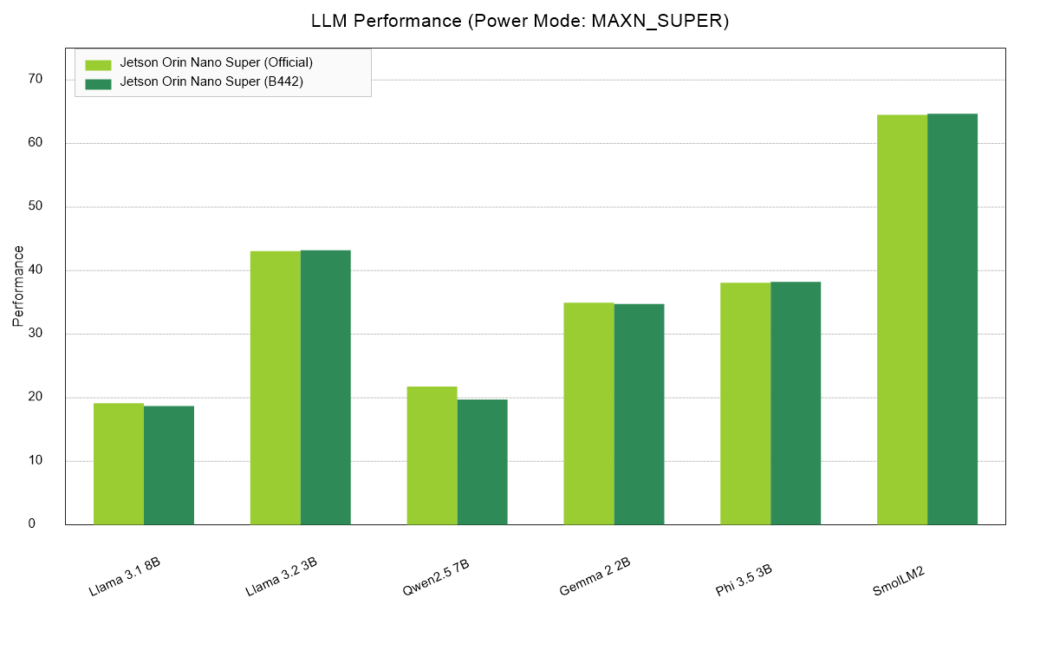  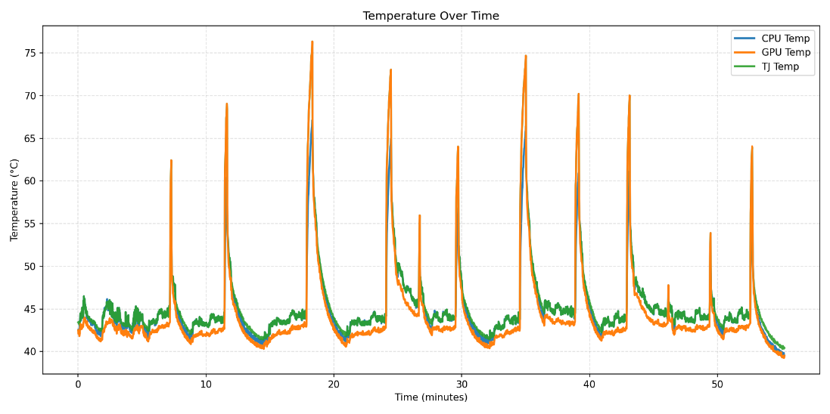  Description of Case Problems:  None
Judgment | Passed

